硬件测试计划 HW Test Plan
 | 文件编号 / Document ID | SGS-FS-HW-xx
 | 密级 / Confidentiality
项目名 / Project Name
项目编号 / Project ID
编制 / Author
审核 / Reviewer
批准 / Approver
日期 / Date
版本 / Version
发布范围 / Distribution list

注意 / Notice:
- 本文档的目的是帮助作者制作满足ISO26262相关要求的工作产品
This document is aimed to assist the author to develop work products in compliance with the corresponding requirements in ISO26262.
- 通过本模板所创建的工作产品不能认为其一定会自动满足ISO26262的要求
The work products generated via this template cannot be treated as are in compliance with requirements of ISO26262 automatically.
- 本文档内容仅供参考
The content of this document is for reference only
- 如有问题，请和我们联系：chad.huang@sgs.com
please contact with us via chad.huang@sgs.com if any question.
- 此模板知识产权归通标标准技术服务（上海）有限公司所有，仅限该咨询项目使用。未经书面许可，禁止打印、复印、转发

模板变更履历 / Template Change History
版本  Version | 状态  Status | 编制人  Author | 编制日期  Date | 批准人  Approver | 批准日期  Approve Date | 内容描述  Description

硬件测试计划变更履历 / HWTP Change History
版本  Version | 状态  Status | 编制人  Author | 编制日期  Date | 批准人  Approver | 批准日期  Approve Date | 内容描述  Description

目录 / Table of Contents
1 概要说明 / General Information 6
1.1 文档目的 / Document Purpose 6
1.2 输入文档 / Input Document 6
1.3 参考文档 / Reference Document 6
1.4 术语和缩略语 / Terms and Abbreviation 6
2 Introduction 7
2.1 Scope of hardware test 7
2.2 Documents, defining the framework conditions 7
3 Test Strategy 7
3.1 Test Strategy in the development process 7
3.1.1 Test goal 7
3.1.2 Test case derive method 7
3.1.3 Test Method 8
3.2 Risk assessment 8
3.3 Test Priorities 9
3.4 Test automation 9
3.5 Re- and regression test strategy 9
3.6 Pass / fail and test exit criteria 9
3.6.1 Pass / fail criteria of the test case 9
3.6.2 Test Coverage and pass rate 9
3.6.3 Test exit criteria 9
3.7 Interruption criteria and resumption requirements 9
3.7.1 Interruption criteria 10
3.7.2 Resumption requirements 10
3.8 Anomaly management 10
4 Test objects 10
4.1 Description of the test objects 10
4.2 Features to be tested 10
4.2.1 HSD1—Brake Light output control 10
5 Test organization 10
5.1 Test activities, expenditures, and schedule 10
5.1.1 Test activities and expenditures 11
5.1.2 Test schedule and responsibility 11
5.2 Traceability 11
5.3 How to proceed test specific tasks 11
5.4 Test work products 11
6 Test environment / infrastructure 11
6.1 Hardware tools 11
6.2 Software tools 12

概要说明 / General Information

文档目的 / Document Purpose
本节描述“硬件组件评估规范”的目的
例：本文档根据前续的评估计划策略，对XXX产品的安全相关硬件组件或器件制定详细的评估方法，包括分析方法/内容，测试用例设计

输入文档 / Input Document
本节描述“系统需求规范”的输入文档，包括但不限于：硬件组件评估的相关流程，相关的安全需求，相关器件的数据手册, 硬件组件评估计划等

序号  No. | 文档名称  Document Name | 文档版本  Version | 文档日期  Date

参考文档 / Reference Document
序号  No. | 文档名称  Document Name | 文档版本  Version | 文档日期  Date

术语和缩略语 / Terms and Abbreviation
术语/缩略语  Terms and Abbreviation | 描述  Description

Introduction
This section briefly describes the test assignment from stakeholder point of view.

Scope of hardware test
Xxx

Documents, defining the framework conditions
Stakeholder expectations for this test level relevant on test planning, specification and execution.
The following documents define the framework conditions form this test plan;
- <Master Test Plan ID revision>
- Milestone plans
- Release objectives
- ---

Test Strategy

Test Strategy in the development process
The definition of the objectives of the test strategy of this test level in the development process shall be detailed here.
In the following the project specific test strategy shall be defined. If a master test strategy has been developed for this project in the master test plan, this strategy will be a refinement for this test level.

Test goal
Following test goals shall consider for the hardware test:
- Verify the completeness and correctness of the implementation of the hardware safety requirements
- Verify the durability, robustness and operation under stresses

Test case derive method
The method listed in the following table shall be select for test case design, the ++ items must be chosen according to the ASIL level.

Methods |  | ASIL |  |  |  | Selection
 |  | A | B | C | D
1a | Analysis of requirements | ++ | ++ | ++ | ++ | Yes
1b | xxxx |  |  |  |  | Please specify the rational if not select.

Test Method
The method listed in the following table shall be select for hardware test, the ++ items must be chosen according to the ASIL level.

- Verify the completeness and correctness of the implementation of the hardware safety requirements.

Methods |  | ASIL |  |  |  | Selection
 |  | A | B | C | D
1a | Functional testing | ++ | ++ | ++ | ++ | Yes
1b | xxxx |  |  |  |  | Please specify the rational if not select.

- Verify durability, robustness and operation under stresses

Methods |  | ASIL |  |  |  | Selection
 |  | A | B | C | D
1a | Environmental testing with basic functional verification. | ++ | ++ | ++ | ++ | Yes
1b | xxxx |  |  |  |  | Please specify the rational if not select.

Risk assessment
The result from the risk classification that will impact the hardware test are shown here:
- Resource
- Timing
- …

Test Priorities
The priority of the test execution results from the risk class. Shares of the risk class “high” are considered first in the test execution.
Priority classification:
High: Safety related functions, new designed module, new components.
Medium: re-use with small change.
Low: completely re-use.

Test automation
This chapter briefly describes the strategy and planned degree of test automation.

Re- and regression test strategy
The definition of the re- and regression test strategy shall be detailed here. An explicit definition, alternative to a reference or a refinement can be given here.

Pass / fail and test exit criteria

Pass / fail criteria of the test case
The definition of the pass / fail criteria shall be detailed here. An explicit definition, alternative to a reference or a refinement can be given here.
- Pass: the test result in the range of the defined expected result.
- Fail: the test result not in the range of the defined expected result.
For each test case, the expected result shall be defined, and the test result must be consistent with the defined expected result. If the test result is not consistent with the expected result, shall follow the anomaly management process to handle it.

Test Coverage and pass rate

Item | Target | Comments
Requirement Coverage | 100% | Specify the rational if not 100%
Pass rate

Test exit criteria
The definition of the test exit criteria shall be detailed here. An explicit definition, alternative to a reference or a refinement can be given here.
- All the test case been executed and reached the defined test coverage and pass rate.
- All the anomalies been report to project team follow the anomaly management process.

Interruption criteria and resumption requirements
In the project often a continuous test execution is interrupted by serious faults. This can result in test abortion, suspension with resumption of the test or by a change of the test object “on the fly”. The definition of the any kind of interruption criteria and resumption requirements shall be detailed here.

Interruption criteria
- Big deviation been found and make the test cannot continue.
- Test sample damaged and cannot repair.
- Test equipment damaged.
- Test case been found not reasonable.
- Design change that the current sample is not available for the test.
- …

Resumption requirements
- Test sample available.
- Test equipment available.
- Test case been clarified or changed.

Anomaly management
For the anomalies identified during the test, please follow the anomaly management process xxx-xxx-xxx and change management process xxx-xxx-xxx.

Test objects

Description of the test objects
Tests are defined for the following test objects:
Version of the design: xxx
This section briefly describes the objects to be tested.
HW module | Sample Phase / HW version | Test Coverage | Test methods
HSD1 | A | 100%
HSD2

Features to be tested
All the features that are tested need to be described and grouped to tests.

HSD1—Brake Light output control
List the features that are tested in this test. (the test specification / test case shall consistency with this chapter)
- Working voltage range
- Output voltage
- Output current capability
- Output feedback voltage
- Self-protection
- Thermal resistance
- Performance of the safety mechanism

Test organization

Test activities, expenditures, and schedule

Test activities and expenditures
The expenditure estimate from the master test plan needs to be detailed and documented. The documentation must be sufficiently detailed to enable other persons who are not members of project team to understand it.

Test schedule and responsibility
It is necessary to schedule the test activities for this test level from the master test plan. Accordingly, the schedule needs to be updated. The test activities should always relate to dates of the development process if possible. Make the schedule as granular as possible.

Traceability
The traceability of the hardware test and system test is built according to the master test plan. The traceability of the hardware test case to hardware requirements shall built according to the attributes.

How to proceed test specific tasks
This section describes / references all “How Tos” which should be applied to specific activities within the test process and which are binding for the test team for this test level.

Test work products
Additional to the test deliverables defined in the master test plan, the following work products are created in this test level and documents the test activities:
  - Log files
  - …
If these work products already been defined in the master test plan, just reference the master test plan here.

Test environment / infrastructure
The necessary and desired characteristics for the test environment and infrastructure shall be defined here. If a suitable test environment / infrastructure is not available at present, these demands are the starting point for the development or purchasing of a suitable environment / infrastructure. If existing test environment or infrastructure fulfils the demands the selected environment / infrastructure shall be listed here ( instead of a listing of the demands).
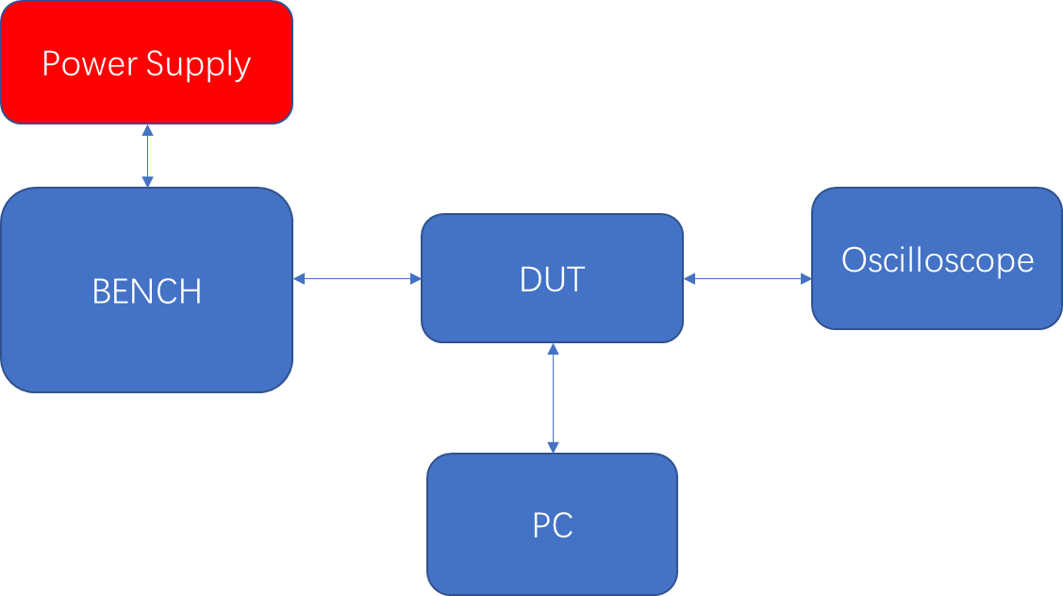

Hardware tools
It needs to be specified here which devices are required for the tests, e.g. emulator, pattern generator, etc. and what amount of hardware tools is required (if applicable: by when)? The calibration information of the equipment shall define here.

Software tools
Which and what amount of software tools are required (if applicable: by when)?

